Innovative: International Multi-disciplinary
Journal of Applied Technology
(ISSN 2995-486X) VOLUME 03 ISSUE 7, 2025

Optimization of Electro-Fenton Based Advanced Oxidation Processes for Pre-Treatment of Biogas Production Using Oily Wastewater to Generate Renewable Energy

Dhay Saadi Naji Algamal
Department of Chemical Engineering, Collage of Engineering , University of Babylon

Abstract:

In the present work removal of organic pollutants present in oily sludge of gas oil storage tanks using advanced oxidation process of electro-Fenton as a pre-treatment method and biological anaerobic digestion as a final treatment was studied. In electro-Fenton method, iron electrodes were used as catalyst and three parameters of pH, concentration of H2O2(as oxidant) and current density were investigated as the most effective parameters on COD removal Three parameters of effluent dilution ratio, amount of co-digestion and concentration of anaerobic sludge were investigated at this step .According to the results of design of experiment using Box-Behnken Design(BBD) method, pH3.51, H2O2 concentration of 9.9 ml per one gram of oily sludge and current density of 15.67 mA cm-2 were selected as the optimum operational conditions. Under these conditions, 87.96% COD removal percent was predicted, where the result obtained from experiments was 83.2%. Interaction effect of both parameters on COD removal was investigated and most interaction was related to the pH and H2O2 parameters. The next step was to treat electro-Fenton effluent using anaerobic digestion method, where date pulp extract was used as co-digestion and anaerobic sludge. According to the results of BBD design of experiment, dilution ratio of 8.9 and 3.6 mL co-digestion, and 6250 mg L-1 MLVSS were determined as optimum conditions, where 98.5% COD removal percent and 68.22 mL methane production were predicted while experimental results demonstrated 90% and 62 mL, respectively. Combination of both methods resulted in 98.32% COD removal percentage.
Keywords: Oily sludge; Advanced oxidation; Electro-Fenton; Anaerobic digestion; Biogas.

1. Introduction
Formation of oily sludge is one of the most important concerns due to maintenance of oil and petroleum products storage units. Solid particles present in stored extracted crude oil with waxy compounds, water and oily emulsion, form sticky sludge at the bottom of the tankers which leads to sever problems such as decreasing storage capacity and corrosion and therefore, routine cleaning of the tanker and extraction of sludgeis necessary. Landfilling or burning with no pre-treatment or treatment, cause severe environmental for ecosystem and human health[1,2].Physical, chemical, and biological processes can be used for reduction of oily sludge pollution[1,2]. Various physical methods have been considered for treatment of oily sludge or separation of valuable compound from it. One of the most conventional methods for separation of different gaseous, liquid, and solid compounds is physical centrifugation which is associated with some disadvantages such as high cost, high noise and secondary pollution of organic agents. As has been mentioned, chemical processes also can be used. However, most of the organic compounds specially, heavy petroleum compounds such as oily sludge, are resistant toward conventional chemical methods[3,4].Using advanced oxidation processes (AOPs) for treatment/pre-treatment of sludge has attracted lots of interests in recent years. Advanced oxidation processes are based on production of highly reactive species such as hydroxyl radicals (OḢ) which are able to convert high non-biodegradable compounds into biodegradable materials. Processes where hydroxyl radicals are produced by electrical energy are noted as electrochemical advanced oxidation processes (EAOPs) which were developed in 90’s and applied successfully for treatment of industrial wastewaters. Final products of these processes are water and carbon dioxide. The electro-Fenton (EF) process is a powerful, novel and environmentally friendly electrochemical advanced oxidation process which is a modification of Fenton reaction[5,6]. In electro-Fenton method, which is an indirect electrochemical method, free hydroxyl radicals are produced with the help of electrical force, which leads to reduced reagents consumption [7].
Single advanced oxidation process is not capable of completely eliminating the pollutants and they can be coupled with biological process (such anaerobic digestion and anaerobic co-digestion) to improve the efficiency of the system for treating oily sludge and other petroleum pollutants. Biogas is generated during anaerobic digestion when microorganisms respires anaerobically and break down organic compounds. Methane produced from anaerobic digestion is considered as a renewable energy source which can be a suitable alternative for fossil fuels[8,9].In addition, simultaneously anaerobic co-digestion of two or more different feedstocks is beneficial and can increase methane yield.
Previous studies have shown that despite great potential of advanced oxidation processes for removal of pollutants, effluent of these processes does not meet requirements of environmental standards. Therefore, investigation of complementary process for treatment of residual pollutant in effluent is necessary. Due to advantages of electro-Fenton method and lack of studies regarding utilization of electro-Fenton in treatment of oily sludge, this method was selected in this study as an effective method. Moreover, due to lack of data regarding investigation of effective parameters, optimization of operational conditions was carried out in the second step of the study.
2. Materials and methods
2.1. Chemical reagents and equipment
Oily sludge was taken from one gas oil tank in the center of Iran. The sludge was transferred to the laboratory and kept in a refrigerator at 4 ºC. All chemicals were purchased from Merck Company.

2.2 Oily sludge pretreatment
Studied oily sludge was acquired and then kept in a refrigerator and required amounts of oily sludge were collected for each test. Oily sludge for electro-Fenton tests was prepared by mixing acquired oily sludge and water with a 1:25 ratio. After that, twin 80 was added to the prepared solution for improved stability (2 mL of twin 80 per 20 g of oily sludge). Afterwards, solution was stirred for 2 h using a mechanical stirrer (240 rpm). Before each test, homogeneity of the prepared solution was assured. Important characteristics of sludge are given in Table 1.
Table 1. characteristics of oily sludge.
parameter | unit | Value
pH (1:25 concentration) | - | 7-8.5
COD (1:25 concentration) | mg L⁻¹ | 16000-23000
TPH | g kg⁻¹ | 196/1615
TDS (1:25 concentration) | mg(NaCl) L⁻¹ | 30-34

2.3. Treatment using Electro Fenton
In the electro-Fenton section, cubic reactor with dimension of 20 cm × 9 cm and 10 cm height was made using Plexiglass with 5 mm thickness. Operational volume of reactor was 300 mL. Three iron electrode pairs was used. Current density was supplied by connecting anode and cathode electrodes to DC power (HY3020 model). Agitation and mixing of the reaction volume was carried out by aeration using aquarium air pump (Hailea) with 80 L min⁻¹ maximum flow rate in order to achieve well distributed and smaller air bubbles. Photo of electro-Fenton reactor is presented in Fig.1.
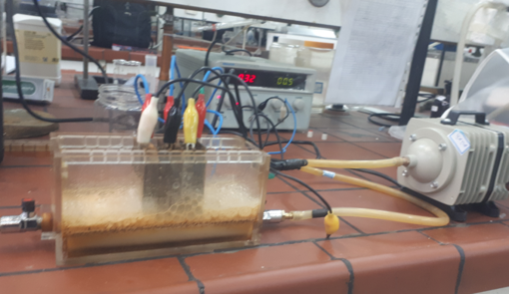
Fig.1.Photo of utilized electro-Fenton reactor with power supply and pump
In electro-Fenton method, 300 mL of wastewater (oily sludge to water mixing ratio of 1:25) was added to the reactor after pH adjustment. Moreover, TDS was set to 2000 mg L-1 based on NaCl salt. Amount of required hydrogen peroxide was calculated based on design of experiments. Required current density was set to a constant value using DC power. Aeration was varied during all tests due to foaming. After 60 min at the end of reaction, solution was centrifuged at 4500 rpm for 10 min. after that, MnO2 was added to the solution in order to eliminate additional hydrogen peroxide and mixed for 24 hr. Then, solution was filtered using filter paper.
2.4. Anaerobic digestion experiments
Details of biological treatment using anaerobic digestion were as follows: According to Table 2, three levels of electro-Fenton effluent dilution (DR), MLVSS of anaerobic sludge, and amount of added date extract as co-digestion agent were investigated using box-behnkn design of experiment. COD removal and methane yield was considered as response.
Table 2. values and levels of parameters in box-behnkn design for anaerobic digestion method.
Variable level (coded) |  |  | Symbol | Variable
-1 | 0 | +1 | Symbol | Variable
0 | 5 | 10 | A | DR
3000 | 6000 | 9000 | B | MLVSS(mg L⁻¹)
0 | 2 | 4 | C | co-digestion (ml)

Anaerobic digestion method was carried out as follows: 100 mL serum bottles with 80 mL operational volume were used. Electro-Fenton effluent was diluted and was added to the serum bottles along with anaerobic sludge and date pulp extract according to values given in Table 2. pH value of samples was measured and adjusted in the neutral range. Before sealing serum bottles, for eliminating oxygen in the samples, nitrogen gas was injected into the bottles. For maintaining complete anaerobic condition, serum bottles were sealed using PTFE septum with aluminum made caps. Samples were placed in shaker at 35 C and 180 rpm. All experiments were repeated twice without adaption. For measuring the amount of produced gas in each serum bottle, gas chromatography (Agilent 6890B, USA) was used. Methane gas measurement was carried out in three steps at 7th (T1), 11th (T2), and 15th (T3) day. COD measurement was conducted on 15th day.
2.5. Analysis
pH determination was carried out according to method 2510A of water and wastewater standard[10].
Chemical oxygen demand (COD), Mixed liquid suspended solids (MLSS), and Mixed liquid volatile suspended solids (MLVSS) was measured using Standard Methods (American Public Health Association (APHA), 1995)[11]. Also, due to high COD value of wastewater (ca. 20000 mg L-1), solution was diluted before COD measurement.
In order to measure content of methane and carbon dioxide, and other gases, 250 uL of sample were taken from serum bottle head space using syringe and was injected in GC unit. GC output diagram is presented in Fig. 2.
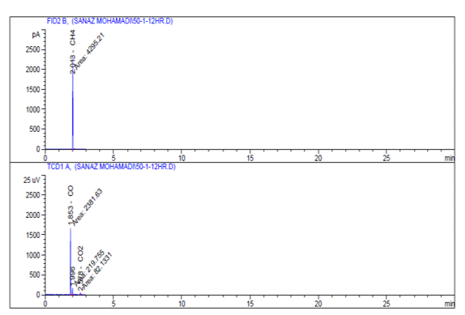

Figure 2. GC analysis diagram.
3. Results and dissection
3.1. Chemical section
By using electro-Fenton method, the results were performed based on experiments provided by the software. Analysis table of variance was formed for the output response, the accuracy of the model was checked, and important and effective parameters were identified. The values of $R^{2} , R_{Adj}^{2} and R_{Pre}^{2}$ for this model were 0.9863,0.9687, and 0.8152, respectively. In addition, unnecessary variables and interactions have been eliminated due to very small interferences, and the response equation of the percentage of COD removal in the purified solution is presented as Equation (1).
COD_{removal} = +40.67200 + 5.65 * H₂O₂ – 0.75572 * CD9.88175+*pH - 039625/0 * H₂O₂* CD -87875/0* pH *H₂O₂-033/0 * CD *pH -015875/0 * H₂O₂²+ 0.03649 *CD ²– 0.116 *pH ²
(1)
3.1.1. Investigate the effect of parameters
Figure 3 shows diagrams of the effect of parameters on COD removal. Figure3-A shows the effect of CD and H2O2 changes on COD removal. By increasing CD from 10 to 30, COD removal present increases with different slope, which indicates interaction of these parameters in the designated range. According to Figure 3-A, rate of increased COD removal percent at greater CD is higher than respective rate at lower CD values. This point out to the interaction of these parameters. At lower CD, effect of increasing H2O2 is more pronounced. While at greater CD values, this effect is diminished and by further increase in H2O2, COD removal percent increases by 5 percent only. However, at lower CD values, removal efficiency increases by 25%. This requires optimization and statistical investigation of these parameters. Probably due to greater amount of produced iron at upper limit of CD, excess iron reacts with hydroxyl radicals and leads to production of Fe(OH)3 and eventually decreased COD removal[10].Figure 3-B shows the effect of pH and H2O2 changes on COD removal. At pH values by increasing H2O2, COD removal percent increases. Increasing rate of COD removal percent at high pH values is smaller in compare to low pH values, which indicates interaction of parameters. Generally, due to formation of different species of iron and hydrogen peroxide, efficiency of electro Fenton depends on pH of the solution. Apart from certain situations, optimum pH for Fenton and electro Fenton processes is reported around three [12, 13]. Activity of electro Fenton reagents in higher pH values is reduced due to presence of oxide-hydroxides of iron and formation of ferric hydroxide precipitation. In these situations where less free iron ions are present, less hydroxyl radical are produced. In fact, oxidation potential of hydroxyl radicals decrease with increasing pH value. Figure3-C shows the effect of pH and CD on COD removal. At low pH values and different CD values, COD removal percent is greater than respective values in higher pH values. Moreover, increasing rate of COD removal percent at upper and lower limit of pH is almost identical with increasing CD and insignificant interaction of parameters is observed. By increasing CD, iron ion production rate on the surface of anode increases. Therefore, pollutant removal efficiency increases by increasing CD. In this study, COD removal efficiency was increased by increasing CD from 15 to 30 mA cm-2. However, due to increased energy consumption and side effects such as side reaction and heat generation, CD must be optimized [12].
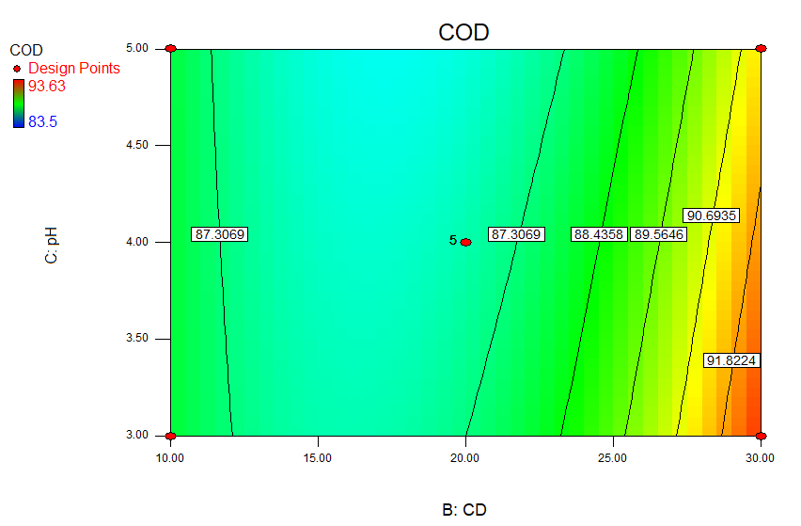
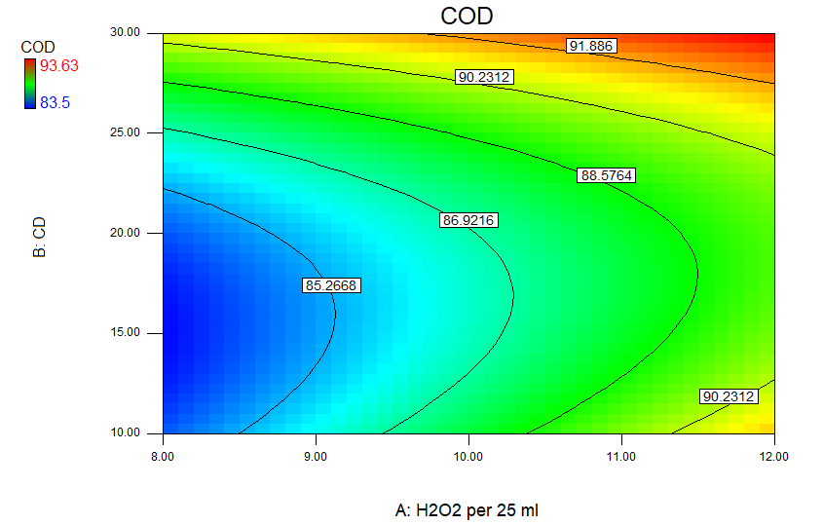
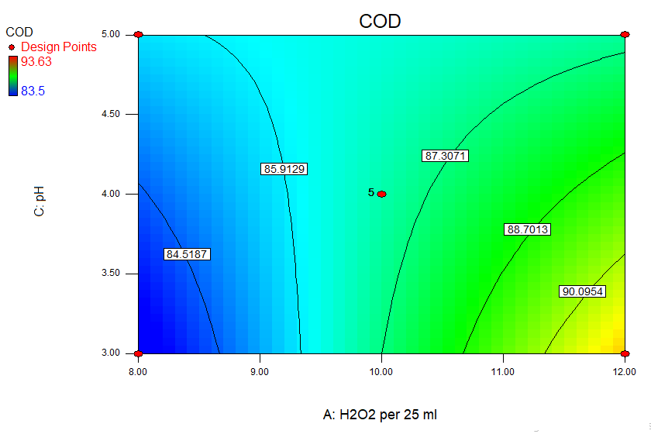
(A)
(B)

(C)

Figure-3 the effect of parameters: (A) CD and H2O2 , (B) pH and H2O2, (C)pH and CD , on COD removal.
Process optimization in the range of parameters was performed by the software with the aim of achieving the highest rate of COD removal in the refined oil sludge. As shown in Table 3, under optimal conditions, the COD removal rate was 83.2%, which is about 4% error compared to software data. Due to changes in the prototype, laboratory conditions, the error of the devices used this error is acceptable.
Table 3: Optimal values predicted by the software for input and output variables
parameter | pH | H2O2 (ml/gr OS) | CD | CODremoval (%)
Optimum condition | 3.51 | 9.9 | 15.67 | 83.2

3.2. Biological section
By using anaerobic digestion method, effect of operational parameters on pollutant removal and biogas production is investigated. Produced methane measurement was carried out in three steps at 7th (T1), 11th (T2), and15th (T3) days and COD was obtained at 15th day of the process. Final calculations and equations for determination of methane production response at three different time intervals and CODremoval percent response using software and eqs. (2) to (5).
Methan T1(ml) = -1.01066 +0.74779 * DR + 0.013 * MLVSS + 5.72625* (2)
codigestion +0.599 * DR * codigestion -9.45E-004* MLVSS * codigestion
-0.17598 * DR ²- 7.74386E-007 * MLVSS ²

Methan T2(ml) = +4.70138 + 4.30589 * DR +6.00208E-003 * MLVSS (3)
+9.23536* codigestion – 0.195* DR * codigestion –1.18292E-003*
MLVSS* codigestion - 0.28709 * DR ²+ 0.69757 * codigestion²

Methan T3(ml) = -1.43375 +4.12586 * DR + 6.85583E-003 * MLVSS (4)
+13.22562* codigestion – 0.16825* DR * codigestion -1.63083E-003*
MLVSS* codigestion - 0.19726 * DR ²

COD Removal (%) = -2.32717 + 8.01602 * DR + 0.013413 * MLVSS (5)
+4.73812* codigestion – 2.34433E-004* DR * MLVSS+ 0.25875* DR*
codigestion - 7.16667E-004* codigestion * MLVSS - 0.3272 * DR² -
7.71506E-007* MLVSS ²
Criteria for suitability of presented model is lack-of-fit parameter and p-value greater than α. Therefore, according to the p-values of current model, suitability of models are confirmed. Also, due to insignificant difference of R-Sq(pre) and R-Sq(adj) equal, it can be said that model is accurate as shown in the table 4.
Table 4 values of $R^{2} , R_{Adj}^{2} and R_{Pre}^{2}$ for methane production at 3 stages andCOD reduction.
COD Removal | Methan  T3 | Methan  T2 | Methan  T1
0.9921 | 0.9908 | 0.9964 | 0.9928 | $$R^{2}$$
0.9841 | 0.9853 | 0.9937 | 0.9873 | $$R_{Adj}^{2}$$
0.9531 | 0.9673 | 0.9844 | 0.9649 | $$R_{Pre}^{2}$$

3.2.1 Investigate the effect of parameters
Figures4, 5, 6 shows effect of operational parameters of anaerobic digestion on methane production and COD removal. Figure4 shows effect of parameters according to coefficient of interaction of DR and MLVSS and elimination of this parameter from equation, interaction of DR and co-digestion and MLVSS and co- digestion during anaerobic digestion is investigated. According to the literature in the context of oily pollutants removal using anaerobic digestion, it has been estimated that steady state is achieved during 15th day of the process [14]. Therefore, COD measurement was carried out on 15th day. Moreover, for achieving better analysis of the interaction of parameters, plot of interacting parameters are presented at 15th day. According to the results, highest methane yield was obtained on 11th day. This is related to the consumption of all digestible substrate and inhibition of anaerobic digestion.

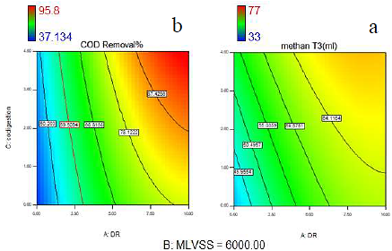

Figure 4 contour plot of interaction of DR and co-digestion (a) methane production at15th day (b) COD removal at 15th day.
Figure 5 shows the Effect of interaction of MLVSS and co-digestion on methane production and COD removal. Fig. 5 demonstrate plot of DR and co-digestion effect on methane production and COD removal at 15th day, respectively. Results demonstrate that effect of interaction between MLVSS and co-digestion on methane production and COD removal percent is significant with more pronounced effects at greater values of MLVSS. At upper limit of co-digestion, with increasing MLVSS, change in methane production yield and COD removal percent is insignificant however at lower limit with increasing MLVSS, methane production and COD removal percent increase significantly, which point out to the interaction of these parameters. At upper limit of co-digestion, due to presence of nutrients with facile digestion, MLVSS increase and F/M decrease lead to insignificant effect on methane production and COD removal. Also, at lower limit of co-digestion, due to high toxicity, inhibition, and low digestion ability, increased MLVSS leads to increased methane production and COD removal percent[15]. As reported by Isam Janajreh et al[16]., presence of heavy metals such as lead and nickel in oily sludge leads to toxicity and inhibition which can be neutralized by increasing dilution rate or increasing MLVSS (reduced F/M ratio).
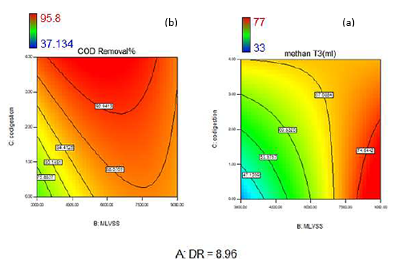
Figure 5 contour plot of interaction of MLVSS and co-digestion (a) methaneproduction at 15th day (b) COD removal at 15th day.
Figure 6 shows the effect of DR and MLVSS on COD removal at 15th day. As said previously, coefficient of interaction between these parameters in methane production equations was eliminated. According to the results, interaction between these parameters is insignificant. At greater dilution ratios, interaction of MLVSS and DR is more pronounced. At DR lower than 9 at high MLVSS concentration, COD removal percent is greater in compare to respective value at lower concentration which is due to toxicity and inhibition effect of feed at low F/M ratio. At DR greater than 9, at upper limit of MLVSS, COD removal efficiency decreases probably as results of significant decrease in F/M ratio.
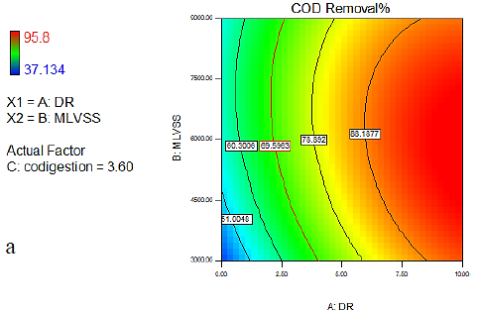

Figure 6 contour plot of interaction of DR and MLVSS
For evaluation of control sample and effect of co-digestion on COD removal percent and biogas production. Accurate evaluation of control sample and activity of anaerobic sample and also effect of date pulp extraction was carried out by investigating distilled water sample and date pulp extract sample at MLVSS=6000. Results are presented in table 5. Also, by evaluation of designed experiments, effect of co-digestion on increased COD removal efficiency and biogas production. Isam Janajreh [16] investigated anaerobic digestion of oily hydrocarbons. By addition of municipal sludge or municipal solid waste as co-digestion, methane production increases significantly. For example, with addition of 40 percent municipal wastewater, at 20th day biogas production was3 fold in comparison with conditions without addition of co-digestion.
Table 5 investigation of anaerobic digestion of control and date pulp extract samplesat MLVSS=6000.
sample | produced methane gas (mL) at 7th day | produced methane gas (mL) at 11th day | produced methane gas (mL) at 15th day | initial COD  (mg/l) | final COD  (mg/l)
distilled water | 35 | 7 | 42 | 290 | 110
date pulp extract | 59 | 50 | 32 | 11420 | 3940

3.3. Results of combination of electro Fenton and anaerobic digestion
According to the results of pre-treatment using electro Fenton and anaerobic digestion and with respect to initial properties of oily sludge (with 1 gr in 25 mL distilled water), overall COD removal percent was 98.32%.
4. Conclusions
In current study, electro Fenton method was selected and results as follows, the optimum operational conditions are pH=3.51, H2O2 =9.9 mL per gr of oily sludge, and CD=15.67 mL cm-2. COD removal percent was predicted equal to 87.96% and actual result was 83.2%. These results demonstrate that electro Fenton as an electrochemical method is suitable for complete treatment of oily pollutants such as oily sludge. After that, in order to increase efficiency of pollutants removal, electro Fenton effluent was treated using biological anaerobic digestion method and results are as follows, date pulp extract was used as co-digestion and anaerobic sludge was used as microbial source. Three parameters of dilution ratio of electro Fenton effluent, amount of co-digestion and concentration of anaerobic sludge were evaluated using box-behnken statistical method. Optimum operational conditions were 8.9 dilution rate, 3.6 mL co-digestion and 6250 mg L-1 MLVSS. Under these conditions methane production at 15th day was predicted to be equal to 68.22 mL and 98.5% COD removal percent, while actual results were 62 mL methane and 90% COD removal percent. Finally, by combination two methods, overall COD removal percent is 98.32%.
References
[1]. كاوياني, ف., بازيافت سوخت مايع از لجن هاي نفتي و تصفيه مواد جامد آلوده به مواد نفتي به روش بيولوژيكي
شركت ملي پالايش و پخش فراورده هاي نفتي ايران
شركت پالايش نفت كرمانشاه, 1386.
[2] امير،, ر.ع.ن.ع.ش.ع.ق.ع.م.س., بازيافت لجن هاي نفتي راهكاري به منظور
. حفاظت از محيط زيست. ششمين همايش ملي و نمايشگاه تخصصي مهندسيمحيط زيست, 1391.
[3] Kobya, M., E. Gengec, and E. Demirbas, Operating parameters and costs assessments of a real dyehouse wastewater effluent treated by a continuous electrocoagulation process. Chemical Engineering and Processing: Process Intensification, 2016. 101: p. 87-100.
[4] ايزدپناه, س., س. احمدحسيني, and س. رضائيان, لجن هاي نفتي، اهميت وروشهاي نوين بازيافت. اولین همایش سراسری محیط زیست، انرژی و پدافند زیستی, 1392.
[5] Chen, H.-S., et al., Research on Treatment of Oily Sludge from the Tank Bottom by Ball Milling Combined with Ozone-Catalyzed Oxidation. ACS Omega, 2020. 5(21): p. 12259-12269.
[6] Mohajeri, S., et al., Statistical optimization of process parameters for landfill leachate treatment using electro-Fenton technique. Journal of Hazardous Materials, 2010. 176(1): p. 749-758.
[7] عصفوري, م.ب.م.ع.ش., بررسی انواع روشهاي نوین و ترکیبی فرایند فنتون جهت تصفیه پسابهاي مختلف. چهارمین کنفرانس بین المللی برنامه ریزی و مدیریت محیط زیست, 1396.
[8] Oturan, N. and M.A. Oturan, Chapter 8 - Electro-Fenton Process: Background, New Developments, and Applications, in Electrochemical Water and Wastewater Treatment, C.A. Martínez-Huitle, M.A. Rodrigo, and O. Scialdone, Editors. 2018, Butterworth-Heinemann. p. 193-221.
[9] Lopes, W.S., V.D. Leite, and S. Prasad, Influence of inoculum on performance of anaerobic reactors for treating municipal solid waste. Bioresource Technology, 2004. 94(3): p. 261-266.
[10] Radwan, M., M. Gar Alalm, and H.K. El-Etriby, Application of electro-Fenton process for treatment of water contaminated with benzene, toluene, and p-xylene (BTX) using affordable electrodes. Journal of Water Process Engineering, 2019. 31: p. 100837.
[11] Diamantis, V., E. Vaiopoulou, and A. Aivasidis, Fundamentals and Applications of Anaerobic Digestion For Sustainable Treatment of Food Industry Wastewater. 2006. p. 73-97.
[12] Babuponnusami, A. and K. Muthukumar, Advanced oxidation of phenol: A comparison between Fenton, electro-Fenton, sono-electro-Fenton and photo-electro-Fenton processes. Chemical Engineering Journal, 2012. 183: p. 1-9.
[13] Rivas, F.J., et al., Oxidation of p-hydroxybenzoic acid by Fenton's reagent. Water Research, 2001. 35(2): p. 387-396.
[14] Haak, L., R. Roy, and K. Pagilla, Toxicity and biogas production potential of refinery waste sludge for anaerobic digestion. Chemosphere, 2016. 144: p. 1170-1176.
[15] Liu, G., et al., Effect of feed to inoculum ratios on biogas yields of food and green wastes. Bioresource Technology, 2009. 100(21): p. 5103-5108.
[16] Janajreh, I., A. Alshehi, and S. Elagroudy, Anaerobic co-digestion of petroleum hydrocarbon waste and wastewater treatment sludge. International Journal of Hydrogen Energy, 2020. 45(20): p. 11538-11549.

